
Sukkur Institute of Business Administration University
Department of Computer Science
BS – I (CS/AI/SE) Fall 2025

Programming Fundamentals
Lab # 06: To become familiar with for loop

Lab Report Rubrics  (Add the points in each column, then add across the bottom row to find the total score) |  |  |  |  | Total Marks
S.No | Criterion | 0.5 | 0.25 | 0.125
1 | Accuracy | - Desired output | - Minor mistakes | - Critical mistakes
2 | Timing | - Submitted within the given time | - 1 day late | - More than 1 day late
Submission Profile
Name: Submission date (dd/mm/yy):
Enrollment ID: Receiving authority name and signature:
Comments: __________________________________________________________________________
Instructor Signature

Note: Submit this lab hand-out in the next lab with attached solved activities and exercises

Objectives
- Understand loops and create programs using them
Loops
Imagine a situation where you want to perform any task several times. For a simple example, suppose you want to print “Hello World” 10 times each on a separate line. Then, you would write cout 10 times (one cout for each line). Something like as shown below:
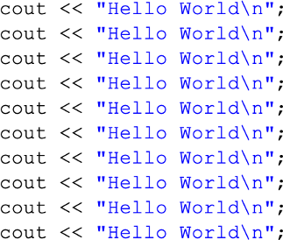
Now, imagine, you want to print something 5000 or 1 million times! Writing 5000 or 1 million lines would not be feasible. To tackle such situations, programming languages provide loops (also called as repetitive or iterative statements).
A loop is a program construct that repeats a statement or group of statements multiple times We write the statement/statements that are to be repeated inside the body of the loop. Each repetition of the loop is called an iteration.
There are two main categories of loops:
- Counter-controlled loops
- Sentinel-controlled loops

Counter-controlled loops
A counter-controlled loop is also known as definite repetition loop, since the number of iterations is known before the loop begins to execute.
The counter-controlled loop has the following components:
- a control variable
- the part that updates the control variable (usually the increment or decrement operation but can be any other operations as well like *, /) at each iteration of the loop.
- the loop terminating condition that checks if looping should continue.
Any task involving definite iteration can be solved using a counter-controlled loop for example printing the first 10 natural numbers.
The for loop is a common counter-controlled loop. Its general syntax is given below:
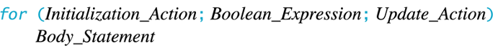
OR
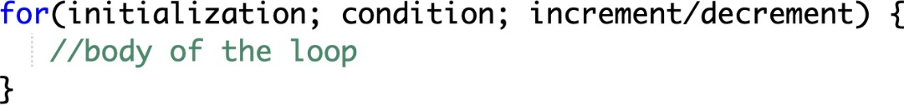
Here
- initialization - initializes variables and is executed only once
- condition – controls the execution of the loop. If it is true, the body of for loop is executed.
    - If it is false, the loop will not run (or when the condition becomes false, loop will stop executing).
- update/increment/decrement - updates the value of initialized variables and again checks the condition to determine if the loop should run once more or not.
Flowchart of for loop in C++

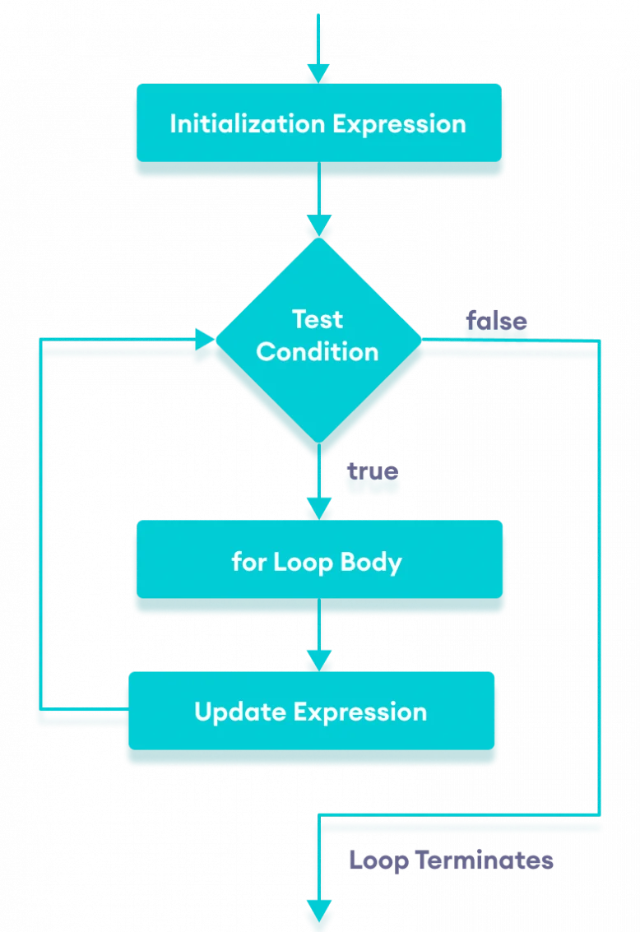

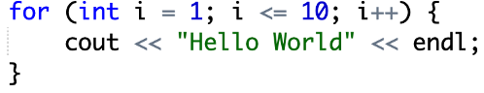
Example:
Output:
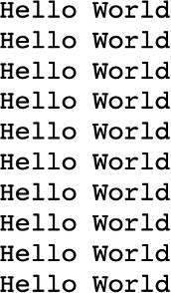
Same like if statement, if there is only one line that needs to be repeated, then you do not need to put the brackets. However, if there are multiple lines that should repeat (or become the body of the loop), then you must write those in the brackets. Otherwise, only one (first) line will be considered the part of loop, the remaining will not be repeated because they would not be part of the loop.
Example 2: Printing Numbers From 1 to 5
#include <iostream> using namespace std;
int main() {
for (int i = 1; i <= 5; i++) { cout << i << " ";
}
return 0;
}

Output:
1 2 3 4 5
Here is how this program works

Iteration | Variable |  |  | Condition (i <= 5) | Action
1st | i | = | 1 | true | 1 is printed. i is increased to 2.
2nd | i | = | 2 | true | 2 is printed. i is increased to 3.
3rd | i | = | 3 | true | 3 is printed. i is increased to 4.
4th | i | = | 4 | true | 4 is printed. i is increased to 5.
5th | i | = | 5 | true | 5 is printed. i is increased to 6.
6th | i | = | 6 | false | The loop is terminated

Example 3: Ask the user to input any range and then find the sum of all numbers from 1 to that range (sum of all natural numbers up to that range value)
// C++ program to find the sum of first n natural numbers
// positive integers such as 1,2, 3,...n are known as natural numbers #include <iostream>
using namespace std;
int main() {
int num, sum; sum = 0;
cout << "Enter a positive integer: ";
cin >> num;
for (int count = 1; count <= num; ++count) { sum += count;
}
cout << "Sum = " << sum << endl; return 0;
}

Output:
Enter a positive integer: 10 Sum = 55

In the above example, we have two variables num and sum. The sum variable is assigned with 0 and the num variable is assigned with the value provided by the user.
Note that we have used a for loop.
for(int count = 1; count <= num; ++count)
Here
- int count = 1: initializes the count variable
- count <= num: runs the loop as long as count is less than or equal to num
- ++count: increase the count variable by 1 in each iteration
When count becomes 11, the condition is false and sum will be equal to 0 + 1 + 2 + ... + 10.

Infinite loop
If the condition in a for loop is always true, it runs forever (until memory is full). For example,
// infinite for loop
for(int i = 1; i > 0; i++) {
// block of code}
In the above program, the condition is always true that will then cause the code to run for infinite time.

Exercises
- Write a C++ program that should ask a user to input an integer number and then displays/prints its table as shown below:

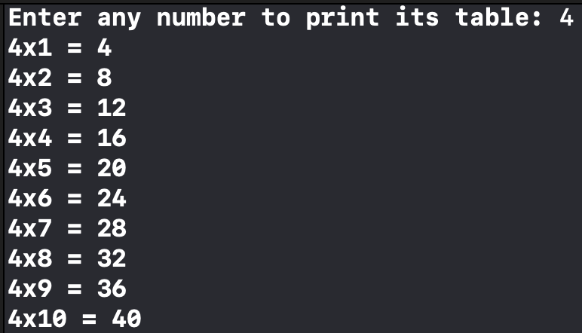

- Write a program that ask user to input the start and the End of the series. Then it prints whole, natural, Even and odd numbers between these ranges. Let’s suppose the user enters value 4 for start, and value 12 for start End.
Then the output of the program:
Enter Starting Number of Series: 4
Enter Ending Number of Series: 12
Whole Numbers: 4 5 6 7 8 9 10 11 12
Natural Numbers: 4 5 6 7 8 9 10 11 12
Odd Numbers: 5 7 9 11
Even Numbers: 4 6 8 10 12

- Write a program that ask user to input the start and the End of the series. Then it prints whole, natural, Even and odd numbers between these ranges but in reverse order. Let’s suppose the user enters value 0 for start, and value 10 for start End.
Then the output of the program:
Enter Starting Number of Series: 0
Enter Ending Number of Series: 10
Whole Numbers: 10 9 8 7 6 5 4 3 2 1 0
Natural Numbers: 10 9 8 7 6 5 4 3 2 1
Odd Numbers: 9 7 5 3 1
Even Numbers: 10 8 6 4 2 0

- Write a C++ program that should ask the user to input the final range up to which the loop should run and then prints ONLY the multiples of 5 (fully divided by 5 only), as
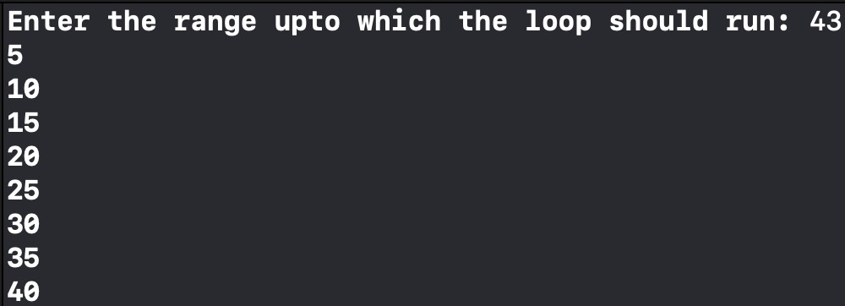
- Write program using a for loop to print a series of 10 numbers as shown below:

- Write a C++ program that asks a user to input the range (final value) up to which the loop should run and then for each number in that range, it should tell whether that (each) number is Odd or Even. For example, if the user enters 7 as the final value of the range, then it should display like following:
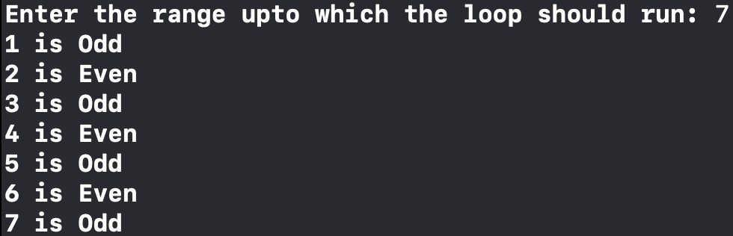
And in another case, if the user inputs 10 as the final value of range, then
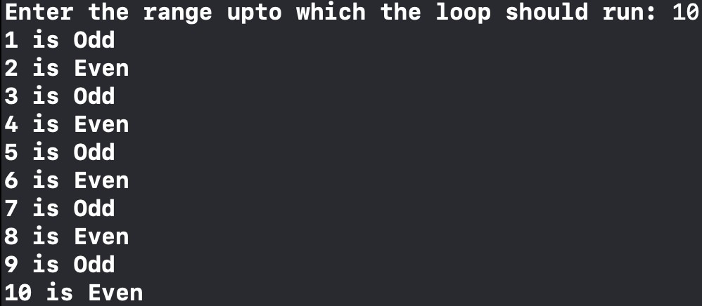
- Using loop, write a C++ program that displays a series of alphabets in ascending order from ‘A’ to ‘Z’ and then in descending order from ‘Z’ to ‘A’.

- Modify your program in the previous part so that the program will display consonants only, no vowels.
- The Fibonacci sequence is a series where the next term is the sum of the previous two terms. The first two terms of the Fibonacci sequence are 0 and 1. The series is as follows:
0, 1, 1, 2, 3, 5, 8, 13, 21, 34, …
Write a C++ program (using loop) to print the 10 numbers of the Fibonacci series as shown above.
- Write a program to ask the user to input n_courses (Total Courses), then iterate loop n_courses time and ask user marks in each course and perform the following tasks:
  - Make sure n_courses is between (3 to 8)
  - Calculate the average of all course marks.
  - Calculate the total percentage of all courses.
  - Tell the user whether she/he is PASS/FAIL, FAIL → less than 60, and otherwise PASS.

Sample output:1:
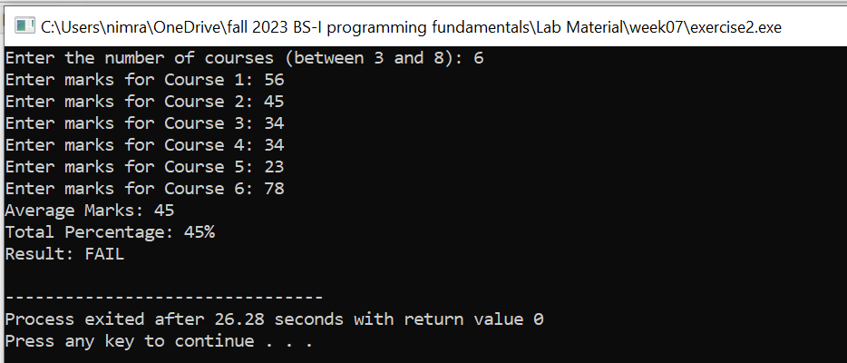
Sample output:2:

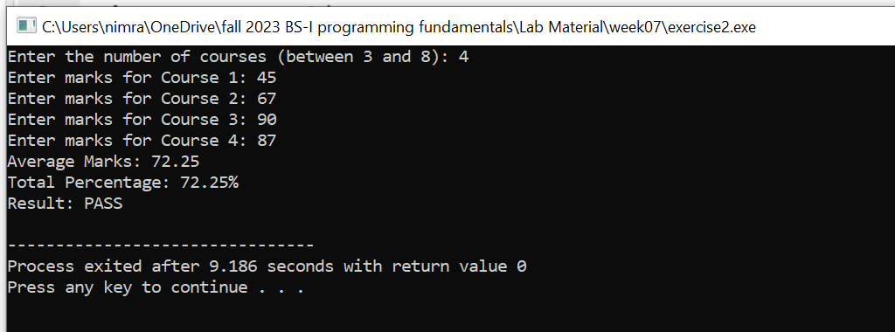

- Write a program to output the N terms of HARMONIC series and their SUM.
